Seven Years World War ~ A game by Joseph Miranda

Sequence of Play Actions Table/ Rule reference
Initiative Phase
Tally campaign markers (CM) value for all controlled powers. Highest moves first and clockwise.
Treasury Phase

- Determine if increasing taxes
- Tally and collect treasury points (TP) in occupied (a unit is in) squares/ one trade routes termini (both if East Indies Trade route)
- Pillaged squares/ ports provide no TPs

29.4 Increasing Taxes Table

Taxation

Free Campaign Markers
- Receive “free” CM per control box if capital is friendly occupied
- Max CM: 14/10/8 for 2/3/4 players game

Major Power Control Box

Recruitment
- Purchase CM
- Play CM “Minor Power Alliance” and roll one die
- Placement of minor powers in major powers territories does not trigger belligerency unless it is enemy-occupied
- Recruit new units within countermix
- Recruit legions with a die-roll less than leader’s CV
- Place units in friendly occupied-unpillaged- civilized squares of the same power not exceeding the square’s treasury value
- Armies must be in home and fleets in port; other units in unpillaged with at least 1 friendly unit
- Optional minor power recruitment after invasion by major power
- Remove pillages

Disband
Player
Phase
29.2 Treasury Cost Chart

29.3 Minor Powers Recruiting Table

P.2
Training
- Convert units to veteran with leader per command point and pay TP
29.2 Treasury Cost Chart
Disbanding
- Remove any friendly units

- Commit diplomacy markers
- Calculate diplomacy differential
- Roll one die
- Check results and place control marker on the map
- Gain enemy or neutral major power by defection (eliminate all units stay with enemy units)
- Revert major power to neutral (removes units to nearest square/ port)
- Examine CM and TP by espionage
- Return CM or leader by coup
- Reaction
- No Diplomacy against minor powers
- Written agreement may take place anytime

29.1 Diplomacy Table
Diplomacy Phase

Major Power Control Box

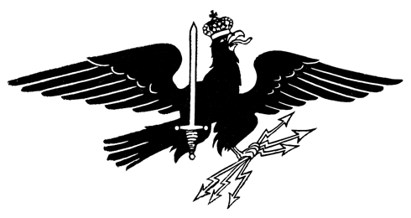
P.3
4.5 Reversion to Neutrality
21.2 Violating agreements
P.4
- No stacking limit per square, only subject to provisioning
- Use slowest unit’s MP in a force
- Use naval MP if naval transport
- May not pick up but may drop off units
- Never enter squares containing enemy or neutral units
- May play “Force March”
- May play “Force March” countermarch (max:1)
- Invasion: Triggers belligerency of neutral major powers for units ending movement
- Least campaign markers per Major Power Control Box player controls the belligerent major neutral power
- Roll a die if ties; lowest die wins
- Play CM “Minor Power Alliance” and roll one die
- Minor power may never cross borders (4.721) unless attack or advance after combat
- Minor power units may never stack with major power units
- Naval: May move through but no stop in fleet occupying squares
- Naval transport: 1 unit per fleet
- Embark/ Debark costs: 0 if in a port, 2 otherwise
29.3 Minor Powers Recruiting Table
Terrain Effects Chart

Major Power Control Box
Movement Phase

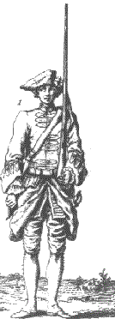
- Play CM “Minor Power Alliance” and roll one die
- Always voluntary
- Attack across square sides
- Determine combat tables to use: Linear, Engagement or Revolutionary
- Always tally all units in defending square
- Drop fractions for odds
- Apply combat modifiers: Leader’s strength and terrain
- Perform advance or retreat after combat, always cost no MP
- Embarked units may advance after combat with a free debark
- Minor powers may advance after combat and must retreat back into its own country
- Attacking minor powers does not trigger belligerency
- CM can only be gained from combat results only if both sides have major powers involved
- Fortified zones and units ignore retreats
- Gain/ Lose CMs
- Upgrade units
- May perform “Force March” Attack
- Fleets cannot attack across adjacent all land square sides
29.3 Minor Powers Recruiting Table
Combat Phase
Provisioning
Phase
Enlightenment
Phase
End
Phase

15.0 Combat Results Table
(50% armies/legions/fleets: Linear;
50% legions: Revolutionary)

Terrain Effects Chart
- Check VP levels
- Negotiate to end game earlier
- Advance turn marker
- Reveal leaders in control boxes

22.1 Victory Points
- Check if number of all units exceeds forage value
- Pay TPs for provisioning excess units
- Remove un-provisioned units
- Neutural and minor units don’t need to be provisioned
Terrain Effects Chart
29.2 Treasury Cost Chart
Pillage
Phase
- Reduce forage value to 0
- Removed by paying TP in recruitment phase
29.5 Pillage Table
- Play 1 CM Diplomacy
- Roll 1 die on Enlightenment Table
- Place on friendly un-pillaged occupied square
- Removed by pillage
29.6 Enlightenment Table

