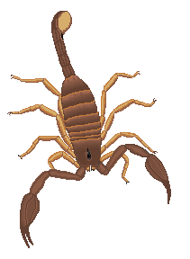  Scorpion  Fights at +1.  If it hits dice again, kills on a 1 or 2. Figure dices each move; if a 6 is thrown the poison has no effect and no more dice need to be thrown. | 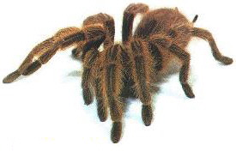  Spider  Fights at +1.  If it hits dice again, kills on a 1 or 2. Figure dices each move if a 6 is thrown the poison has no effect and no more dice need to be thrown. | 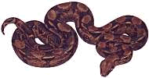  Snake  Fights at +2.  If it hits dice again, kills on a 1 or 2. Figure dices each move if a 6 is thrown the poison has no effect and no more dice need to be thrown.
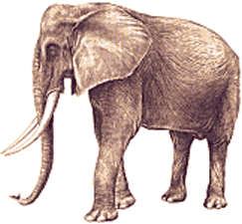  Elephant  Fights at +3.  On playing this card a rogue elephant appears six inches from any of your opponents figures. He moves at 2 x D6. He has a saving throw of 3 or better against any except white men, Regulars, Soldiers, Artillery, Machine Gun or Gunboat. | 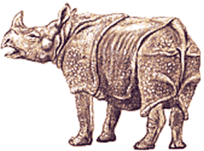  Rhino  Fights at +3.  On playing this card an unhappy Rhino appears six inches from any of your opponents figures. He moves at 2 x D6. He has a saving throw of 3 or better against any except white men, Regulars, Soldiers, Artillery, Machine Gun or Gunboat. | 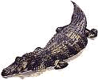  Crocodile  Fights at +2.  This card places a crocodile within six inches of a riverbank, moves at 1 x D6. No saving throw.
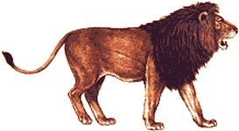  Lion  Fights at +2.  This card places a lion within six inches of the opponents figures, moves at 3 x D6. No saving throw. | 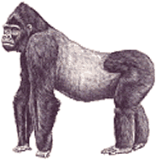  Gorilla  Fights at +2.  May be placed in cover and springs an ambush anywhere within 3 inches. No saving throw. It may also be played against any figures in cover. | 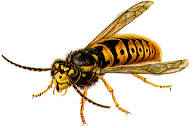  Hornets  Played on any figures anywhere except in boats. Can be from a ground nest, in a tree, or under the eaves of a house. Any figures within 6 inches either take a morale test to remain, which cannot be negated, or throws 3 x D6 and moves directly away in the opposite direction to their current facing. Any figure going off table is lost to the game.
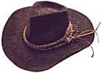  Quicksand  Played immediately in front of an opponents figure. Figure falls in on anything but a six, except a scout or pygmy falls in on a 1 or 2. Any other figure except a scout or pygmy falls in within an inch except on a 5 or 6. | 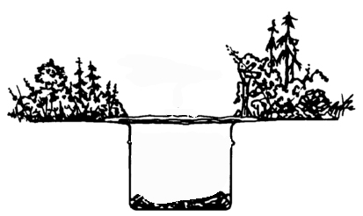  Animal Pit  Played immediately in front of an opponents figure. Figure falls in on anything but a six, except a scout or pygmy falls in on a 1 or 2. Any other figure except a scout or pygmy falls in within an inch except on a 5 or 6. | 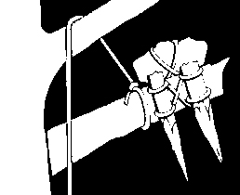  Spear Trap  This card springs a spear trap. It fights at plus 3 once against a selected figure, if fired enfilade it may skewer two, the second at plus 2.
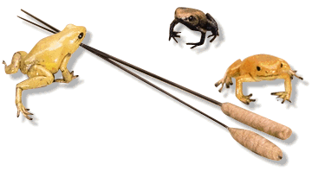  Poison Arrow  This card springs a poison arrow. It fires at plus 1. If it hits then dice again, kills on a 1 or 2. Figure dices each move if a 6 is thrown the poison has no effect and no more dice need to be thrown. | 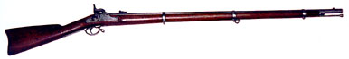  Damp Powder  Played on any musket-armed unit, which has not fired yet, not white men, regulars, or soldiers. Player throws 1 D6 on a 1, 2 or 3 his powder is damp. He can attempt to clear next or subsequent move on a 5 or 6. If a 1 is thrown the unit’s whole powder supply is damp. Powder may be borrowed from a second unit it is in contact with. But the muskets must still be cleared, ignore further 1’s. | 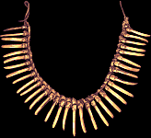  Burial Ground  May be played on any native unit. Remains in play. Native unit and any subsequent native unit must take a morale test to cross. Can be negated by a witch doctor’s chanting that move who it does not affect.
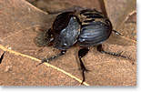  Rare Specimen  Before you is a rare specimen of the lumbago Dung Beetle. You bend over to place it in your specimen jar and the spear, shot, shell, arrow flies over your head. Played to negate a hit (A figure behind is not so lucky and takes the hit instead). | 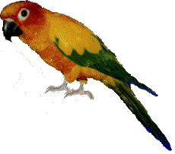  Parrots  The harsh cackle of the Lesser Sulphur Crested Effluent Cockatoo distracts your opponent. Any shot or arrow whizzes off harmlessly, -1 in combat to the opponent. | 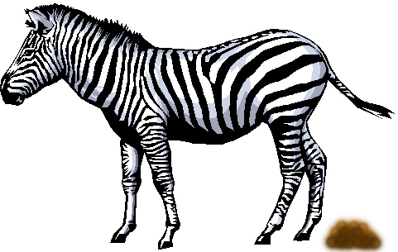  Zebra Faeces  One opposing figure steps in it; any shot or arrow goes wild, -1 in combat.
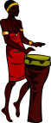  Jungle Blasters  Friendly natives start beating their drums. The effect negates your opponent’s standard-bearer. Drums continue until a 1 is thrown on a subsequent move when the drummers take a long nap instead. | 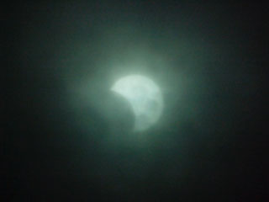  Eclipse  A sudden eclipse of the sun, which you told your side about, completely disconcerts the enemy. They make no movement or reloads if non whites but point to the sky. They may defend if attacked at –1. Sun re-appears next move. | 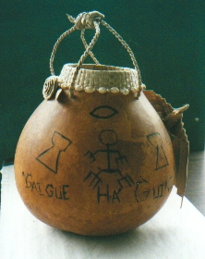  Magic Potion  The opponent’s witch doctor has prepared little potions to deflect bullets. Each time a native is shot dice of 1 indicates that the witch doctor is revealed as a quack and departs the table in shame. Played at any time and remains in force.
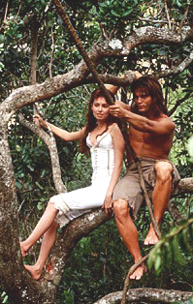  Vine  A handy vine just when you need it. Swing across any terrain feature. Remains in play but dice for each figure on a 1 it breaks. Any figure on it falls off half way over the feature. No harm unless into a river, bog, quicksand, chasm, etc. |   Glass Eye  Instead of plunging his assegai into your vitals your opponent is amazed as your glass eye pops out and rolls at his feet. One figure is not killed this turn in hand to hand; the opponent’s strike is cancelled. | 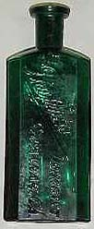  Doctor Froggets Cure All  Your mum packed a bottle of Froggets Cure All. If hit by a poison arrow drink it. 4, 5, and 6 it works! Throw 1 D6 and that’s the number of doses available. Retain to drink. Also can be used on snake, spider and scorpion stings.
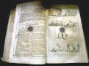  Chalmers Guide to the Dark Continent  Containing tips and hints for exploration you keep a copy in your top left pocket. It saves against any bullet or arrow that strikes. Shocked by the damage to such a precious tome you place it in your haversack where it will be safe. May only be used by a WHITE MAN. | 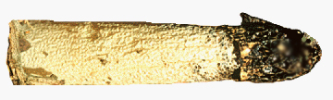  Phallic Symbol  She who must be whacked about a bit, gave you a symbol to improve your virulence, it swings in a pouch over your vitals. It saves you from shot or arrow. After being hit the clay prick shatters, you mutter stupid cow and carry on. Can only be used by a native.
  Home Made Jam  As you are knocked backwards by the thrust of your enemy’s blade, your freshly looted jar of Home Made Redcurrant Jam breaks, you strike your head and fall still. Believing you dead and gutted, the opponent passes you by. Can be used after removal of a ‘dead’ figure to reinstate him to his previous position. | 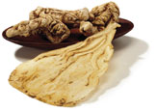  Gnarled Root  As you are knocked down in the fight you hand grips a gnarled root that you swing at your opponent. You re-dice one combat. | 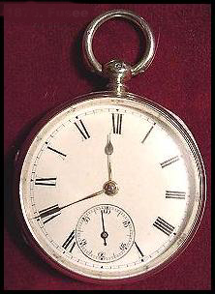  Grandfather’s Pocket Watch  As an opponent/animal attacks you your watch chimes and to the surprise of your opponent, who deducts –2. Can only be used once.
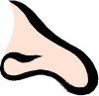  Bad Smell  The animal or Scout attacking you is really repelled by your smell and turns 180 degrees, throw 2 x D6 to find new location (doesn’t leave table). Animals attack nearest figure, Scouts move as normal next turn when fully recovered. | 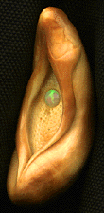  Lucky Charm  That funny shaped lucky charm that old woman sold you really works. Use this card to re-dice any one dice throw affecting your troops, or change this card for the top card in the card pack. Use only once. | 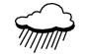  Downpour  A sudden rainstorm prevents all muskets from being used and deducts –1 from bow fire, clears any subsequent move on a roll of 5 or 6.
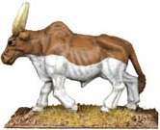  Ronga Card  Cattle  1/5  Can be used to attempt to buy off an attacker. Dice again & continue. | 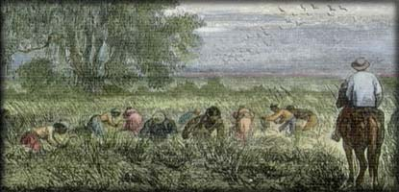  Ronga Card  Slaves  2/5  Can be used to attempt to buy off an attacker. Dice again & continue. | 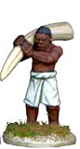  Ronga Card  Ivory  3/5  Can be used to attempt to buy off an attacker. Dice again & continue.
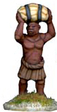  Ronga Card  Cloth  4/5  Can be used to attempt to buy off an attacker. Dice again & continue. | 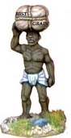  Ronga Card  Grain  5/5  Can be used to attempt to buy off an attacker. Dice again & continue. | 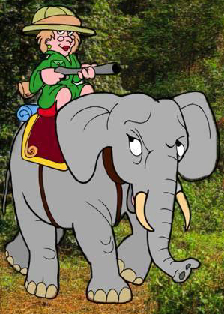  Ronga Card  Guns  Wild Card  Usable as substitute for any one of the 5 main Ronga Cards.  Can be used to attempt to buy off an attacker. Dice again & continue.
Ronga  Card | Ronga  Card | Ronga  Card
Ronga  Card | Ronga  Card | Ronga  Card

